**Percentage Discount**

The product information api added a percentage discount i.e. :

<http://tibamoja.co.ke/ws:allproducts?from=0&to=100>

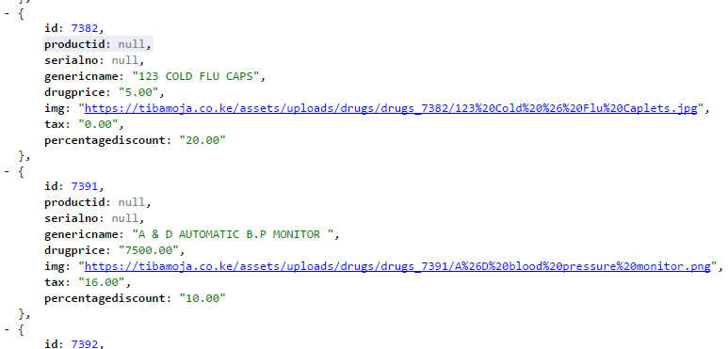

The webapp, items with a discount will display the special discount label as below:

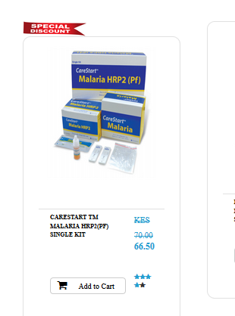

Products discount are entered by the admin in the backend:

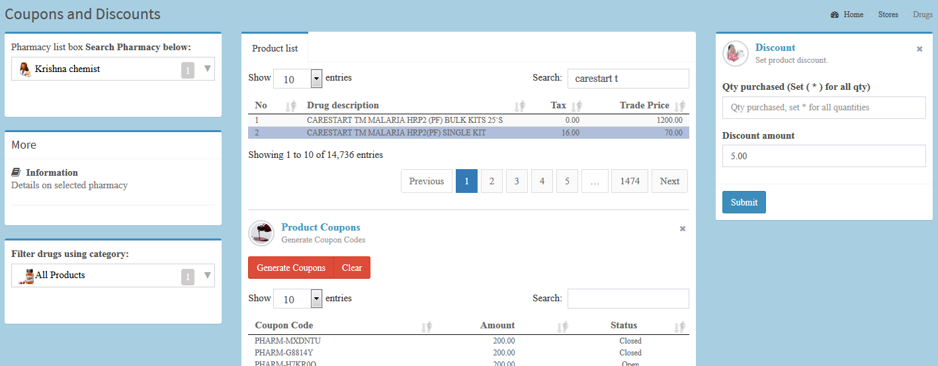

**Grid Display**

Fixed the corresponding email and addresses of the patient.

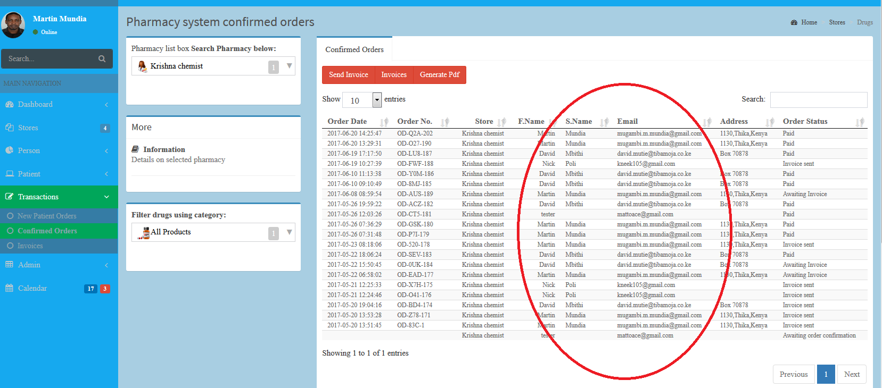

**All the email templates have been changed to allow fill screen, below is a sample email:**

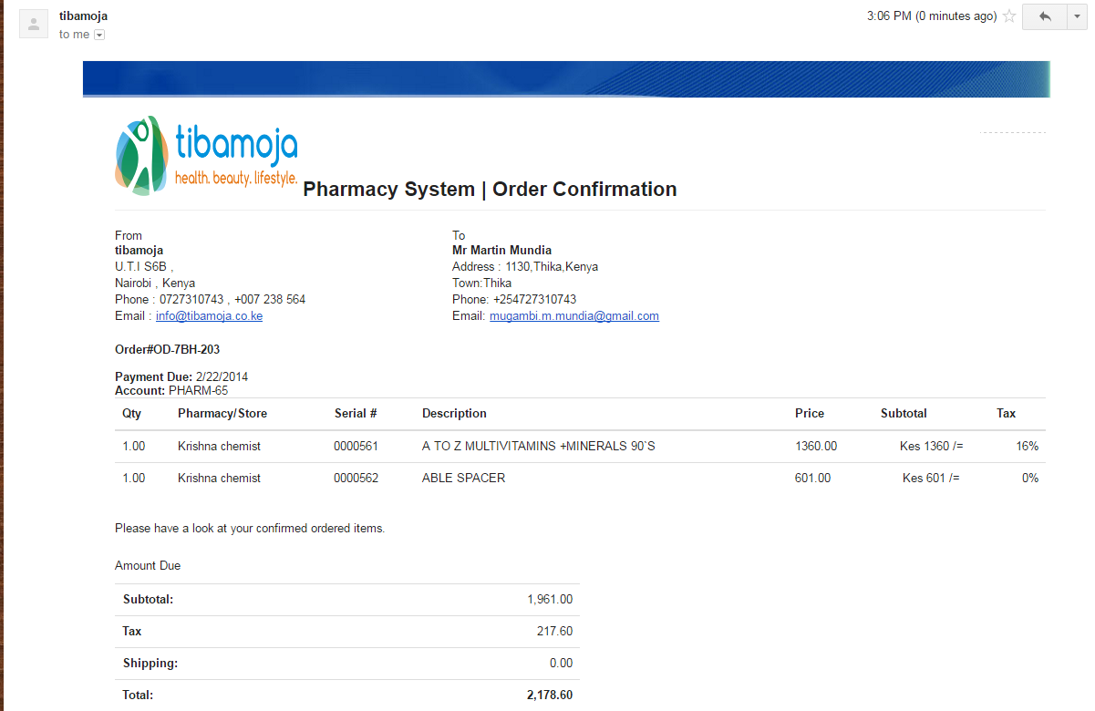

**Below is a sample of the new invoice template:**

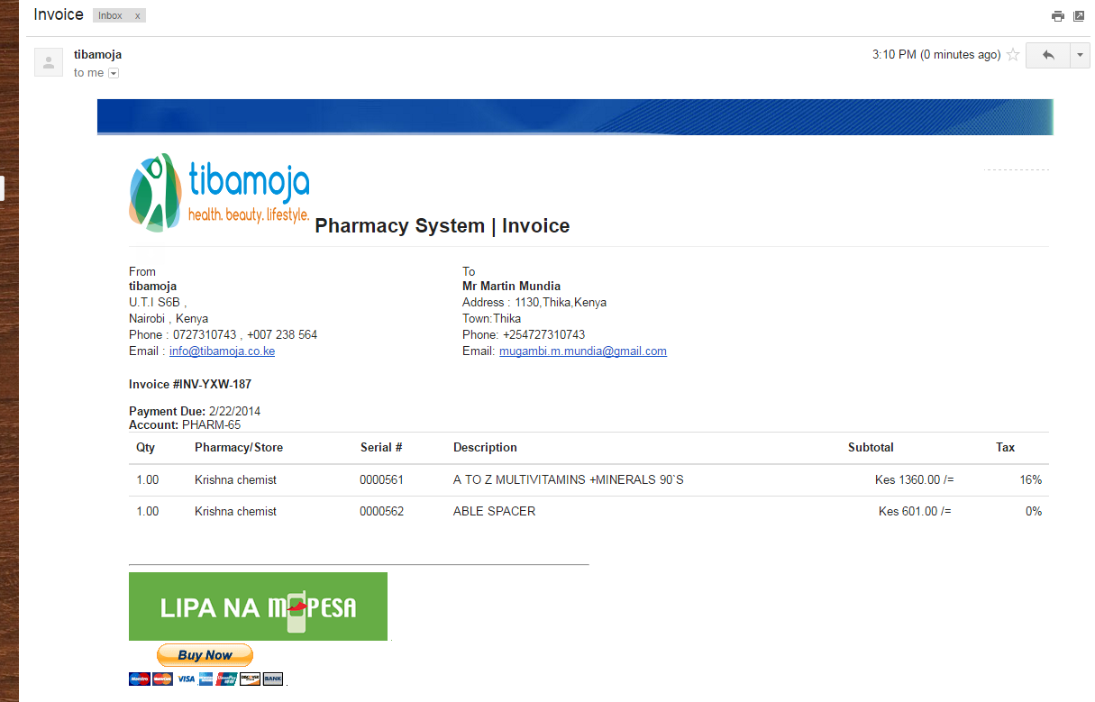

**Below is the corresponding mobile view of the invoice:**

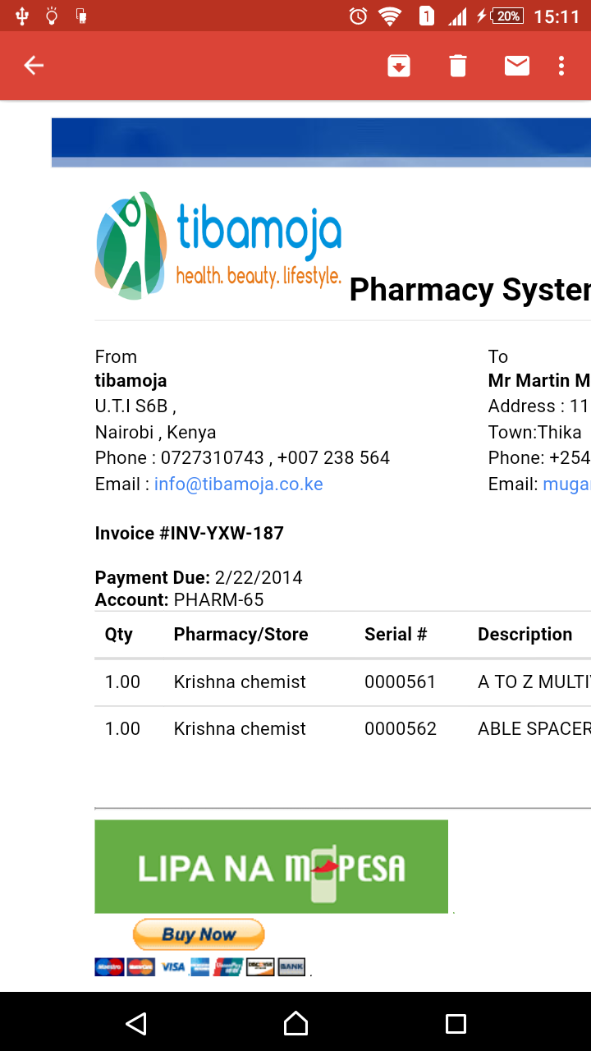

**And the final screen to finalize the transaction as shown:**

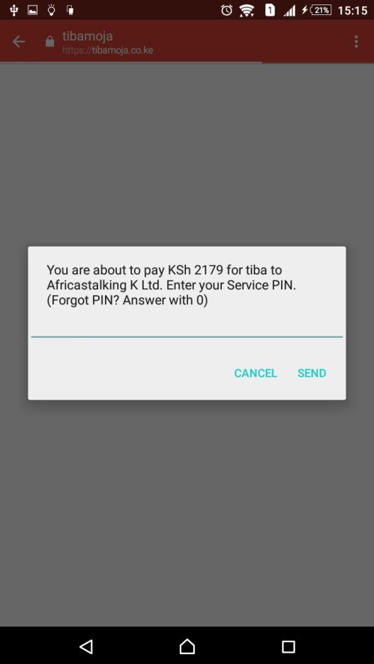

**New user registration form has been changed to allow entry of the google work/home locations as below:**

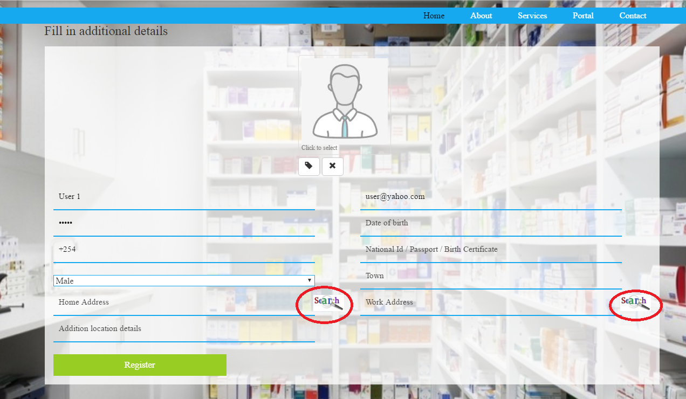

**On click of search option to drag or search to your work location is enabled.**

